**Project Analysis**

**Mohamed Ibrahim**

## System Requirement Specification:

### Functional System Requirement:

**There are two sub modules in this phase.**

* Teacher module.
* Administrator module.

**The functionality of each module is as follows:**

* **Teacher module**: The teacher will login to the software and design new exam (manually or automatic). He can also view and print old exams, add new chapter, question.
* **Administrator module:** The administrator manages users, groups, manage courses, chapters, questions and exams.

**The features that are available to the Administrator are:**

* The administrator has the full management on system.
* Can create/delete an account.
* Can view the accounts.
* Can change the password.
* Can hide any kind of features from the both of users.
* Insert/delete/edit the course data.
* Insert/delete/edit the chapters data.
* Insert/delete/edit the questions data.
* Insert/delete/edit the exams data.
* Design exam manually from chapters.
* Design exam automatic from chapters.
* Can Print exams

**The features available to the Teacher are:**

* Can change password.
* Can view his courses
* Can view his exams
* Design exam manually from chapters.
* Design exam automatic from chapters.
* Can Print exams
* Can add chapter to course
* Can add questions to chapter

### Non-Functional System Requirements:

#### Performance Requirements

Some Performance requirements identified is listed below:

* The software shall support use of multiple users at a time.

#### Safety Requirements:

The database may get crashed at any certain time due to virus or operating system failure. Therefore, it is required to take the database backup.

User validations on forms (client side – server side)

#### Security Requirements:

Some of the factors that are identified to protect the software from accidental or malicious access, use, modification, destruction, or disclosure are described below. Keep specific log or history data sets

* Assign certain functions to different modules
* Restrict communications between some areas of the program
* Check data integrity for critical variables
* Later version of the software will incorporate encryption techniques in the user/license authentication process.

1. Communication needs to be restricted when the application is validating the user or license. (i.e., using https).

## Use Case:

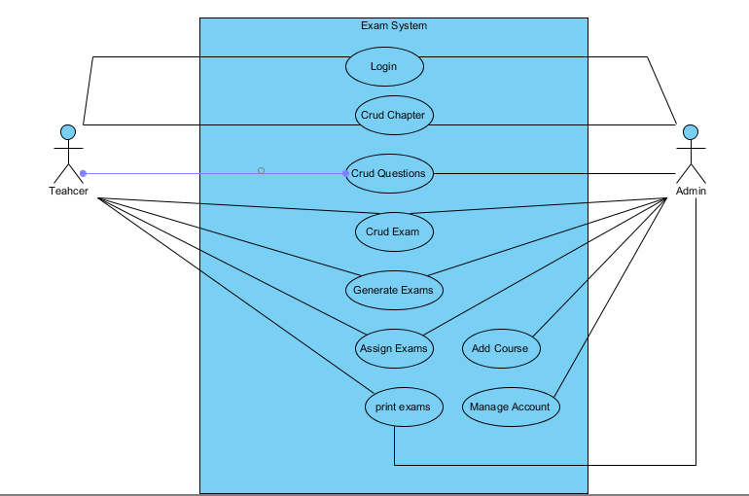

## ERD:

